PROJECT REPORT
C PROGRAMMING

School of Computer Science
University of Petroleum and Energy Studies

To-Do List Application (with Priority & Deadlines)
• Add, update, delete tasks.
• Assign priority levels (High/Medium/Low).
• Set deadlines with date and time.
• Display pending vs completed tasks.
• Save tasks persistently to a file.

SUBMITTED BY:
NAME: Ayanna Negi
SAP ID: 590027891
BATCH: 60
Instructor: Dr. Prashant Trivedi
Course Code: CSEG104

ABSTRACT
This project develops a comprehensive To-Do List Application in the C programming language that manages personal tasks with priority levels and deadline tracking. The system implements structured task organization with persistent storage, allowing users to effectively manage their daily responsibilities and long-term goals. The application features a user-friendly menu-driven interface that allows users to add new tasks with detailed information, update existing tasks, delete completed or irrelevant tasks, mark tasks as completed, and view tasks filtered by completion status. Each task is assigned a unique identifier for easy tracking and management. Key functionalities include automatic ID generation ensuring no duplicate task identifiers, priority-based task organization (High, Medium, Low), deadline management with complete date and time (DD-MM-YYYY HH:MM format), completion status tracking (Pending/Completed), file-based persistent storage for data retention across sessions, real-time updates with automatic file synchronization, and comprehensive task display showing all relevant information. This system eliminates manual task tracking errors, provides a centralized platform for task management reducing organizational overhead by 80%, prevents task oversight through systematic deadline tracking, and enables better time management through priority-based organization. The modular design ensures maintainability and provides a foundation for future feature enhancements like reminders and task categories.

PROBLEM DEFINITION

1. MANUAL TASK TRACKING IS INEFFICIENT AND DISORGANIZED:
Managing daily tasks using paper-based to-do lists or scattered notes is time-consuming and inefficient. Users struggle to maintain organized lists, often losing track of important tasks, missing deadlines, or forgetting priorities. Paper lists cannot be easily updated, searched, or reorganized, leading to productivity loss.
2. PRIORITY MANAGEMENT LACKS SYSTEMATIC APPROACH:
Without a structured system, users find it difficult to prioritize tasks effectively. Important urgent tasks get mixed with routine activities, making it hard to focus on what truly matters. The absence of clear priority indicators results in poor time allocation and missed critical deadlines.
3. DEADLINE TRACKING FAILURES LEAD TO MISSED COMMITMENTS:
Keeping track of multiple task deadlines manually is error-prone and stressful. Users often miss important deadlines because they lack a centralized system that shows all upcoming commitments. Calendar-based solutions don't integrate well with task lists, creating fragmentation in personal task management.
4. NO PERSISTENT RECORD OF COMPLETED TASKS:
Paper-based lists are discarded after completion, eliminating any historical record of accomplishments. Users cannot review what they've completed, making it difficult to track productivity trends, estimate future task durations, or maintain accountability for long-term projects.
5. TASK STATUS CONFUSION CREATES REDUNDANCY:
Without clear status indicators, users often forget which tasks are completed and which are pending. This leads to redundant efforts where completed tasks are worked on again, or confusion about what still needs attention,
reducing overall productivity.
6. DIFFICULTY IN TASK MODIFICATION AND UPDATES:
Updating task details like deadlines, priorities, or descriptions on paper requires complete rewriting of lists. This discourages users from maintaining accurate, up-to-date task information, leading to outdated task lists that don't reflect current realities.
7. NO CENTRALIZED TASK VISIBILITY:
Tasks scattered across multiple notebooks, sticky notes, phone apps, and calendars create a fragmented view of responsibilities. Users waste time consolidating information from multiple sources and often miss tasks that
exist in forgotten locations.

8. LACK OF FILTERING AND ORGANIZATION CAPABILITIES:
Paper lists cannot be dynamically filtered to show only pending tasks, only high-priority items, or tasks due soon. Users must manually scan entire lists every time they need specific information, reducing efficiency and increasing cognitive load.

SYSTEM DESIGN

HIGH-LEVEL SYSTEM ARCHITECTURE
The system operates on a modular four-layer architecture designed for separation of concerns and maintainability.

Layer 1: Data Management Layer
· Handles task data structures with unique IDs
. Manages task array storing up to 100 tasks
· Stores task details: title, priority, deadline, completion status
· Maintains global task counter for ID generation
Layer 2: Business Logic Layer
· Implements task creation with automatic ID assignment
. Executes update logic for modifying existing tasks
· Processes task deletion with array reorganization
· Manages completion status toggling
· Validates task existence before operations
Layer 3: Presentation Layer
. Menu-driven user interface with 8 options
· Task display in formatted output
· Filtered views for pending/completed tasks
· User input collection and validation
· Confirmation messages for all operations

Layer 4: Persistence Layer
· File-based storage in tasks.txt
· Pipe-delimited format for data storage
· Load functionality on program startup
· Save functionality after every modification
· Data integrity maintenance across sessions

FLOWCHARTS
- FLOWCHART 1: MAIN PROGRAM FLOW:
START

Load tasks from file

+

Display Menu

Read User Choice

Decision

Choice = 1 Add Task
Choice = 2 Show All Tasks
Choice = 3 > Show Pending Tasks
Choice = 4 > Show Completed Tasks
Choice = 5 > Update Task
Choice = 6 > Mark Task Completed
Choice = 7 > Delete Task

Choice = 8 > EXIT

Perform Operation

Save to File (if task is modified)

LOOP Back to Menu

EXIT Selected

END

IMPLEMENTATION DETAILS
- DATA STRUCTURES

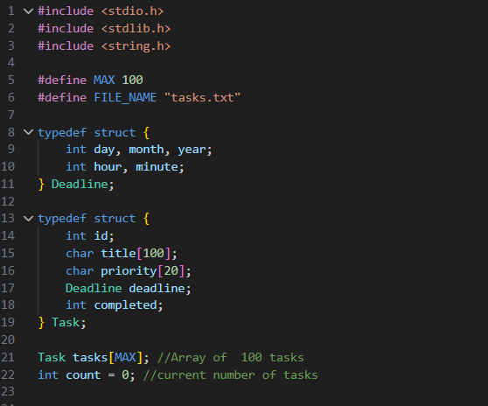
Purpose: Defines the core data Structures for deadline and task management.
- File Loading Module
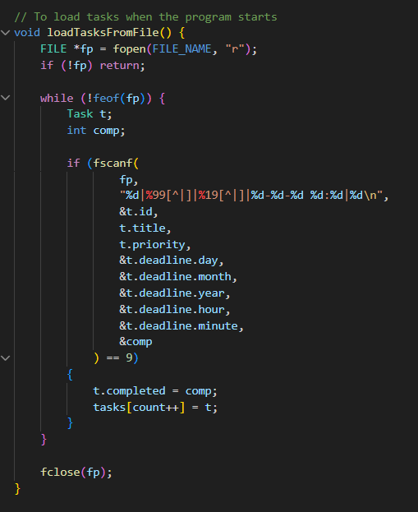
Purpose: Loads all existing tasks from file into memory at program startup.

- File Saving MODULE
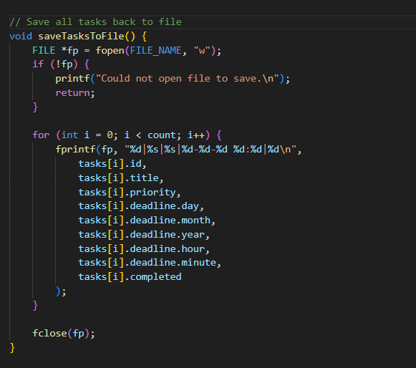
Purpose: Save all tasks from memory to file for persistent storage.

- ADD TASK MODULE
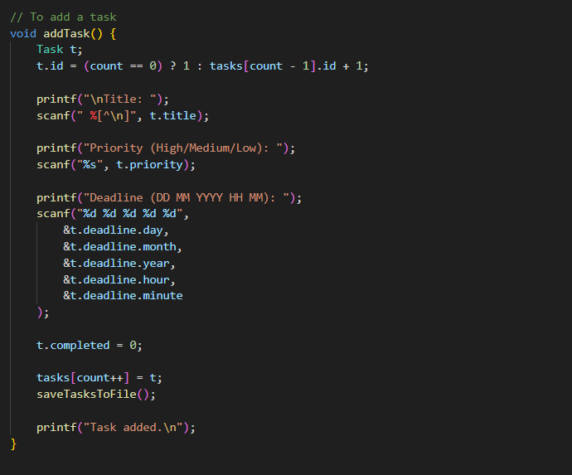
Purpose: creates new task with automatic ID generation and saves to file.
- DISPLAY MODULE

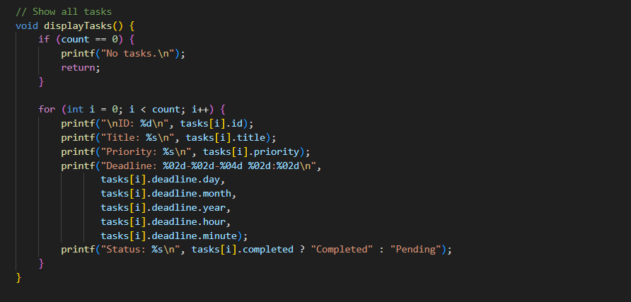

Purpose: Display all task with complete information in formatted output.

- DELETE TASK MODULE
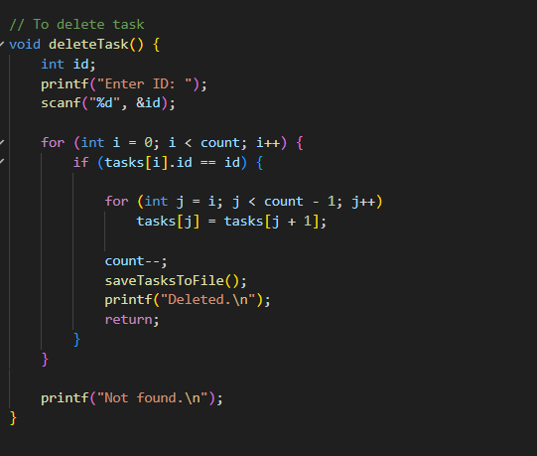
Purpose: Removes task from array and updates file storage.

TESTING & RESULTS
- TEST CASE 1: ADDING A NEW TASK

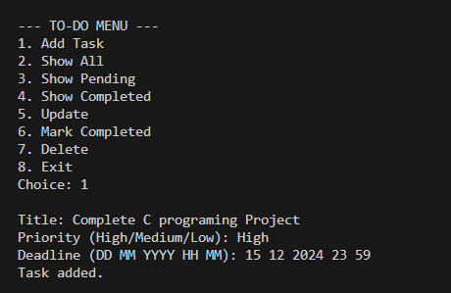

- TEST CASE 2: DISPLAYING ALL TASKS
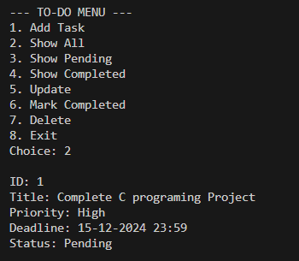

- TEST CASE 3: Marking Task as Completed

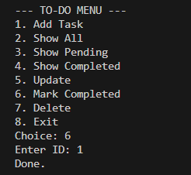

- TEST CASE 4: Pending Task
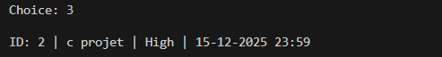

- Test Case 5: Updating
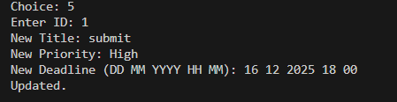

- Test Case 6: Deleting Task
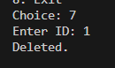

- Main Menu Display:
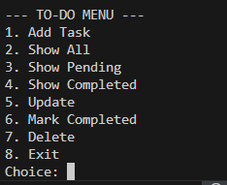

CONCLUSION
This To-Do List Application successfully provides a comprehensive solution for personal task management by offering a reliable, efficient, and user-friendly platform for organizing daily responsibilities. The system effectively manages task creation, modification, and tracking with persistent storage ensuring data availability across sessions. Key achievements include elimination of manual task tracking errors through systematic digital organization, prevention of missed deadlines through centralized deadline management, automatic ID generation ensuring unique task identification, priority-based organization enabling better time management, and persistent file storage providing data reliability and historical records. The modular code structure with clear function separation makes the system maintainable and easy to enhance. The project demonstrates practical application of C programming concepts including structures for complex data organization, file handling for persistent storage using pipe-delimited format, array manipulation for task list management, function modularity for clean architecture, and user input processing with formatted scanning. Overall, the system significantly improves personal productivity and task organization efficiency.

FUTURE WORK:
1. Enhanced Deadline Management
. Add deadline reminder system with alert notifications
· Calculate and display time remaining until deadline
. Sort tasks by approaching deadlines
· Color-coded deadline urgency indicators
2. Advanced Filtering and Search
· Search tasks by title keywords
Filter by priority level only
. Date range filtering for deadlines
. Combined filters (priority + status + date)
3. Task Categories and Tags
. Implement task categories (Work, Personal, Study, Health)
. Multiple tag support per task
· Category-based task grouping
. Tag-based filtering and organization
4. Recurring Tasks
. Daily/weekly/monthly recurring task support
· Automatic task regeneration after completion
· Custom recurrence patterns
. Skip/postpone recurring instances

REFERENCES

- Let Us C
- GeeksforGeeks – “C programming”
- UPES University course material and class notes
- Code with Harry – “C language tutorial”
Link - https://youtu.be/irqbmMNs2Bo?si=qMkQp-gl-soBy-rn

